**Module – 5**

**Exp 3: TRANSMISSION OF PING MESSAGE**

**Aim**: Simulate the transmission of ping messages over a network topology consisting of 6 nodes and find the number of packets dropped due to congestion.

TCL file-

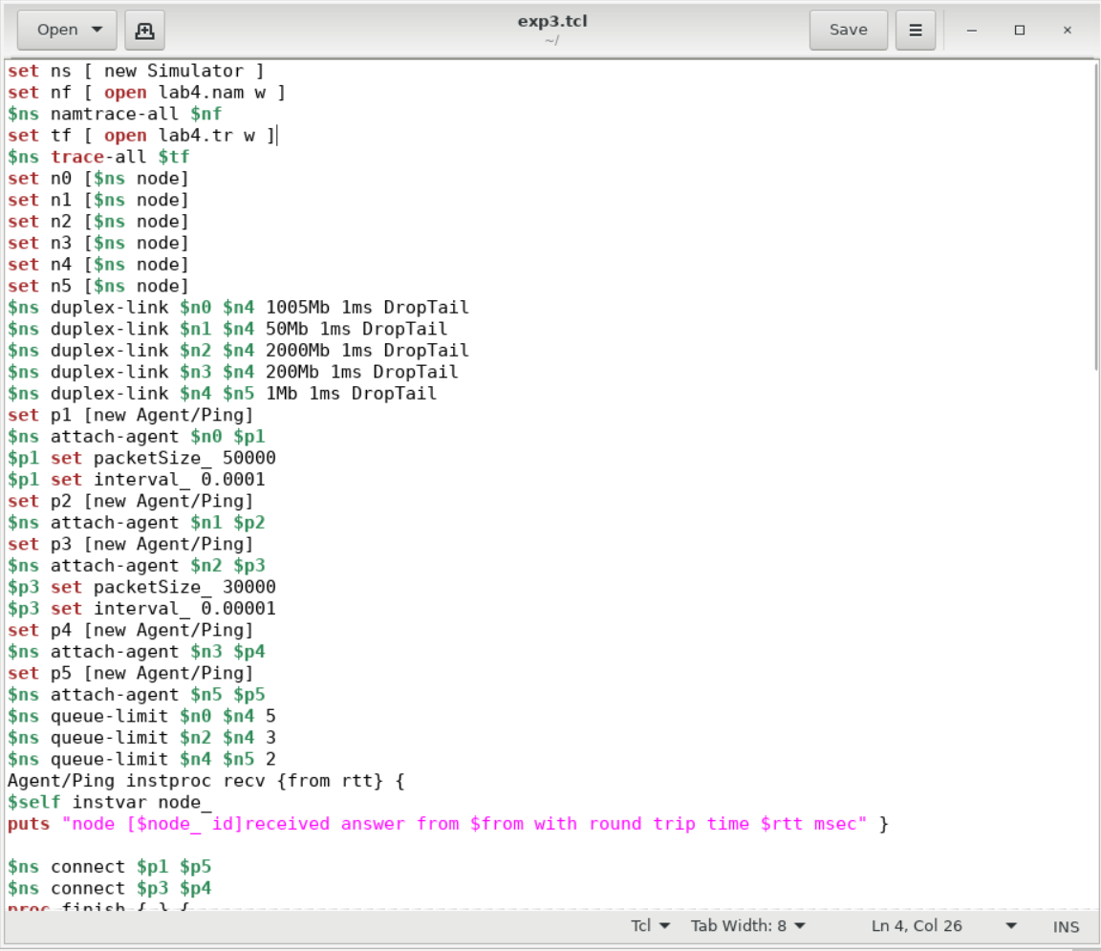

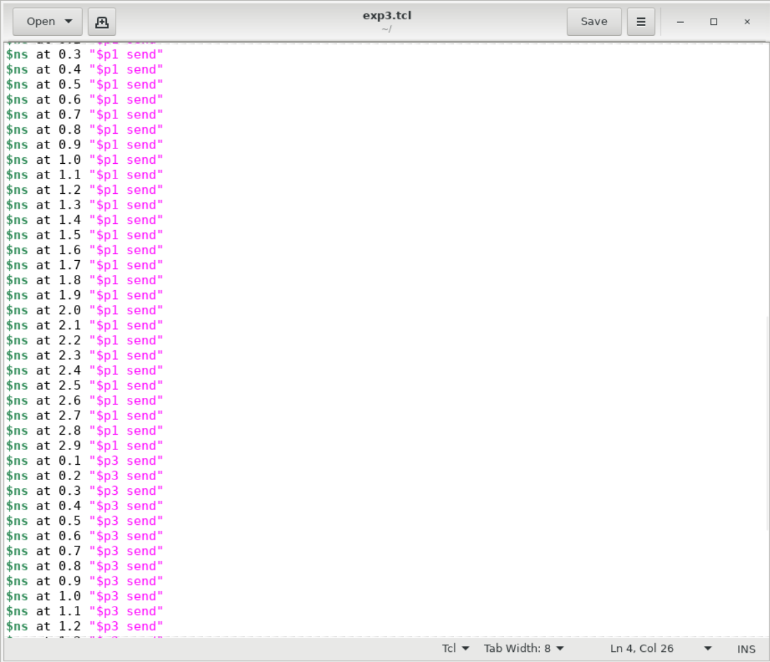

AWK File:

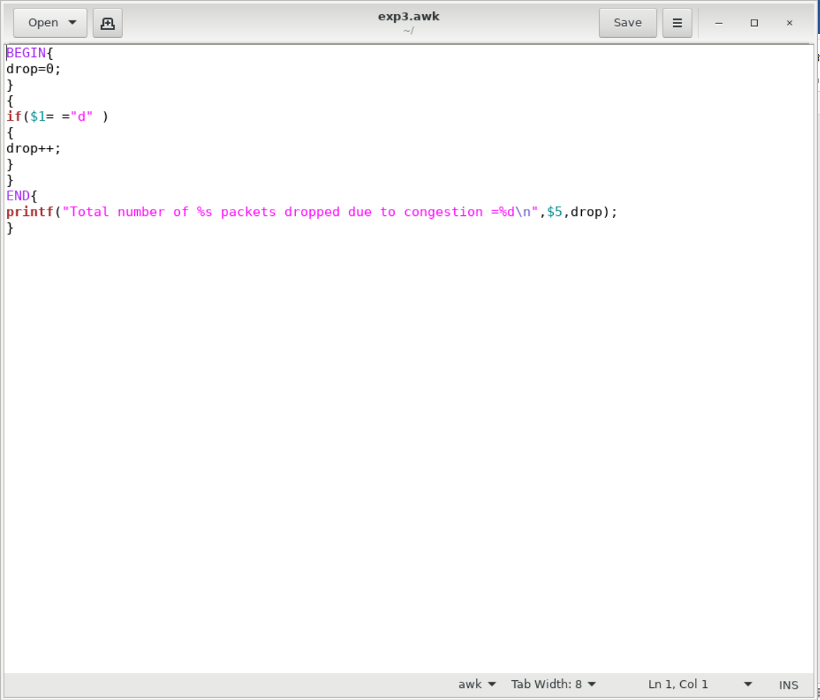

OUTPUT:

